GRAPH 1K:

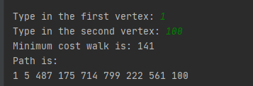

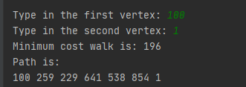

GRAPH 10K:

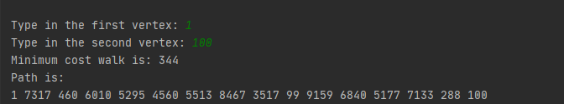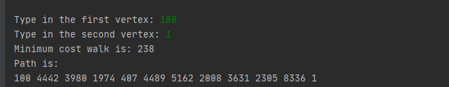

GRAPH 100K:

